

Ankara Yıldırım Beyazıt University

Department of Computer Engineering

CENG 201 – Object Oriented Programming  
Course Project

GROUP 7: Expense Tracker Application

Analysis Report

Furkan İÇTÜZER,   
Serhat ERDOĞAN,  
Selim ÇENTELİ,   
Sümeyye Feyza YEMENOĞLU,  
Saidahmad USMANALIEV

**Instructor**: Muhammed Abdullah Bülbül

**Teaching Assistant:** Elif Şanlıalp, Yusuf Şevki Günaydın

**Date:** 01/11/2024

**Table of Contents**

1. Introduction 2

2. Requirements 2

2.1. Functional Requirements 2

2.2. Non-Functional Requirements 3

3. System Models 3

3.1. Scenarios 3

3.2. Use Cases 3

3.3. Object and Class Model 3

3.4. User Interfaces 3

4. Conclusion 3

# Introduction

In this project, an expense tracking application is planned to build. This application allows multiple users to have different profiles and users are will be able to record their expenses, categorize spendings, generate reports about their expenses, and also set monthly budgets. In addition, the system warns the user by sending notifications if they are close to exeed the limit.

# Requirements

## Functional Requirements

* Allowing different users
* Saving expenses
* Categorizing expenses
* Generating expense reports
* Setting budgets
* Exceeding the Limit Notifications
* Be able to see if the monthly / full payments done or not
* Near Miss payment Notification

## Non-Functional Requirements

* Logging a record should be done less than one minute
* System should be able to store multiple users
* Each user could have at least 50 expense records capacity
* There should be mode choice (Light Mode / Dark Mode)
* In the application, 1 month will pass as 1 minute in real time.

# System Models

## Scenarios

Scenario 1:

User Ali signed in to his account with his password and username. He checked is there any payments left from “Territorial Credit” from “Territorial Credit Category”. He saw that he paid all installments from there. He exit the application.

Scenario 2:

User Fatma got a notification about her Grocery Shopping payment should be paid. She signed in to her account with her username and password. She checked “Grocery Shopping Category” and paid the charge. Then she changed the situation of the expense as paid.

Scenario 3:

User Merve signed into her account with her username and password. She viewed her last 2 expenses from Last Expenses and categorized them as “Clothing Expenses”.

Scenario 4:

User Mehmet logged in to his account with his password and username and viewed “Digital Device Expenses” from “Digital Device Expenses Category”. Then, paid all arrears from that category and changed situation of the expense as paid.

Scenario 5:

User Sevda signed in to her account with her username and password. She entered Get Report and chose "Weekly Report". In Weekly Report page she determined the start date of the week, then she chose the "Automabile Category". Finally she clicked Generate button and got her Weekly Report

Scenario 6:

User Ali logged in to his account with his username and password. He chosed Set Budget, and from there he added a new Budget by entering the amount "1,000 TL", category "Luxury Expense", and the name "Luxury Budget".

Scenario 7:

User Zeynep signed in to her account with her username and password. She entered a new 200 TL expense. Then, she got a notification about she has 100 TL left from her Monthly Budget, otherwise she will exeed the limit.

## Use Cases

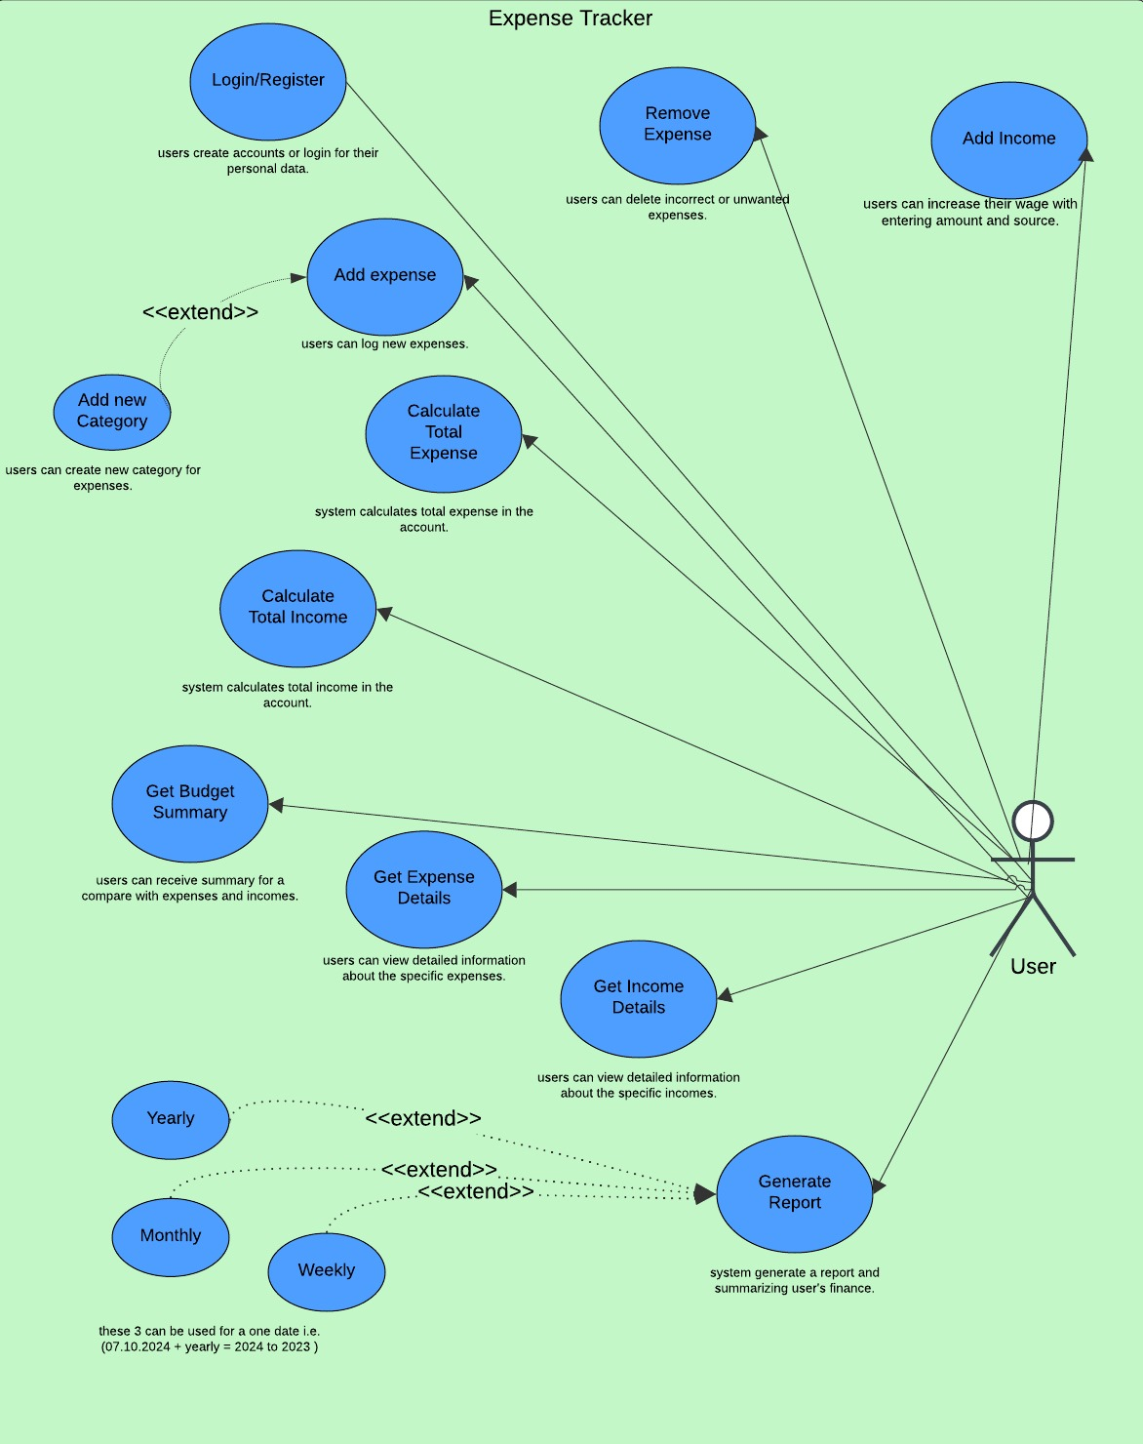

**Figure 1. Use-case diagram**

## Object and Class Model

* + User
  + Category
  + Budget
  + Expense
  + ExpenseManeger
  + RepeatedExpense
  + NonRepeatedExpense
  + FileManeger
  + Report
  + WeeklyReport
  + MothlyReport
  + YearlyReport
  + ReportGenerator

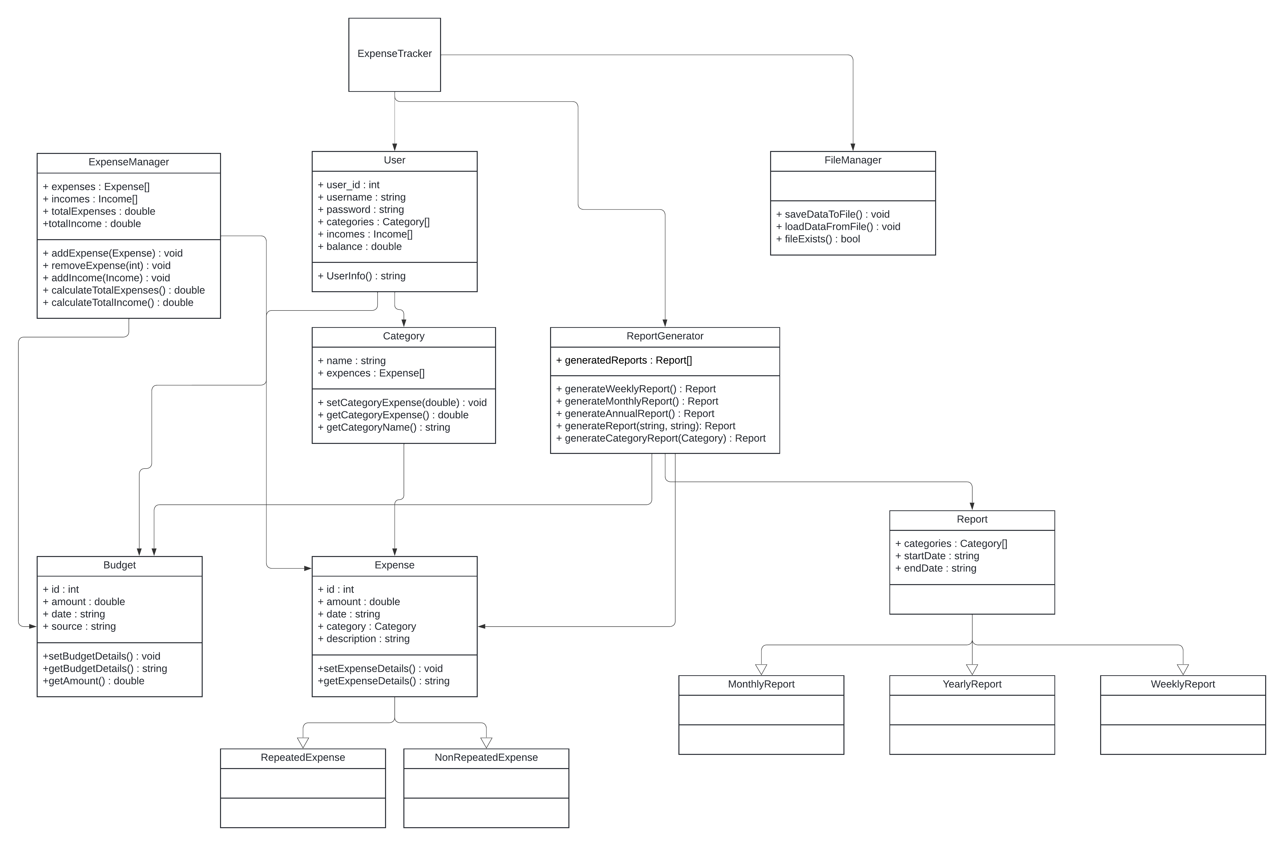

**Figure 2. UML Diagram**

## User Interfaces

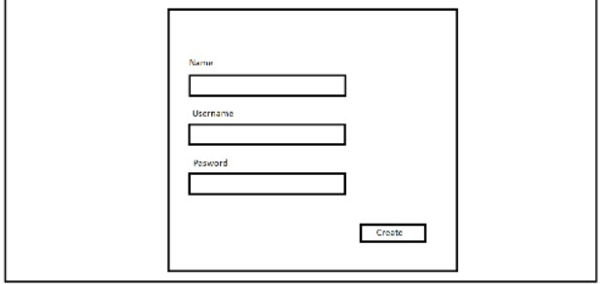

**Figure3.1 Register page**

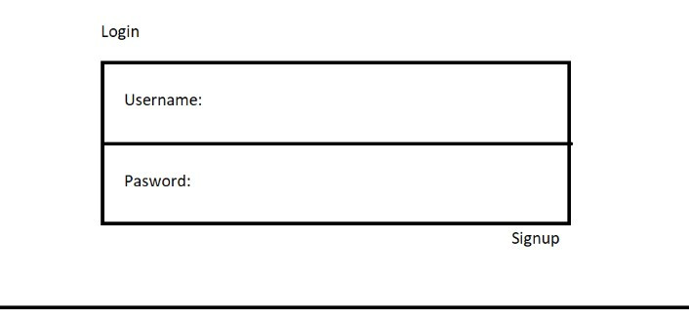

**Figure 3.2. Login page**

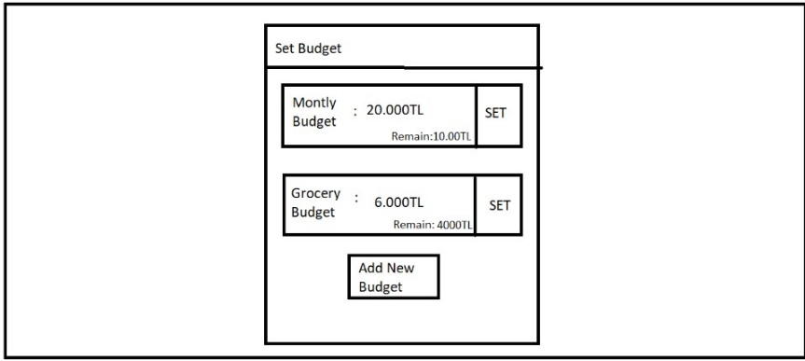

**Figure 3.3. Budget page**

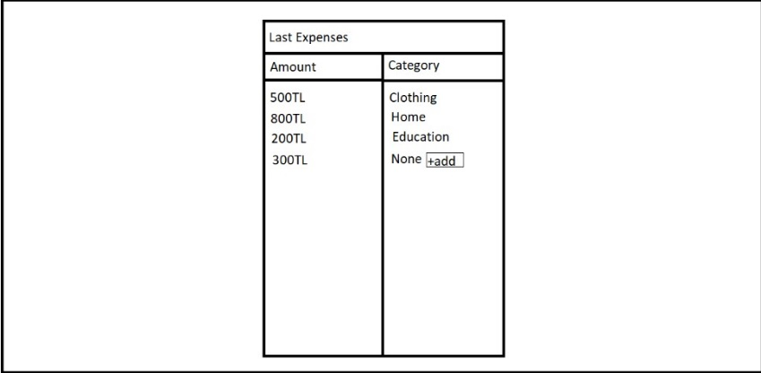

**Figure 3.4. Expenses page**

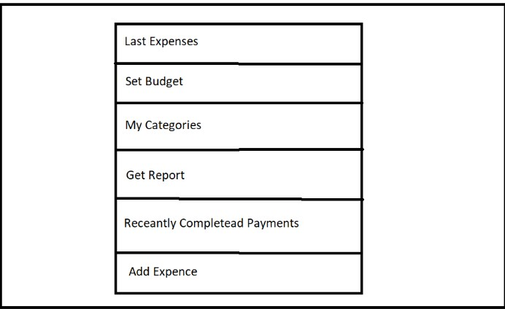

**Figure 3.5. Main menu**

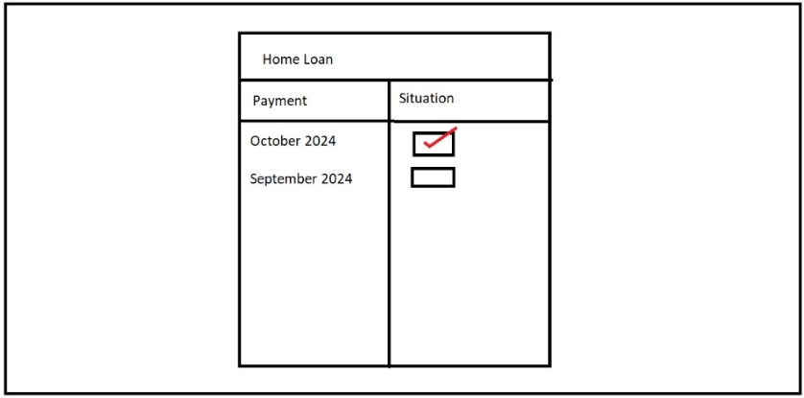

**Figure 3.6. Category’s page**

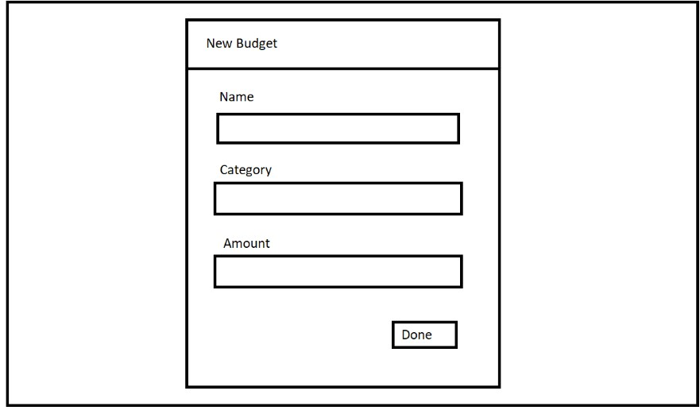

**Figure 3.7. Add budget page**

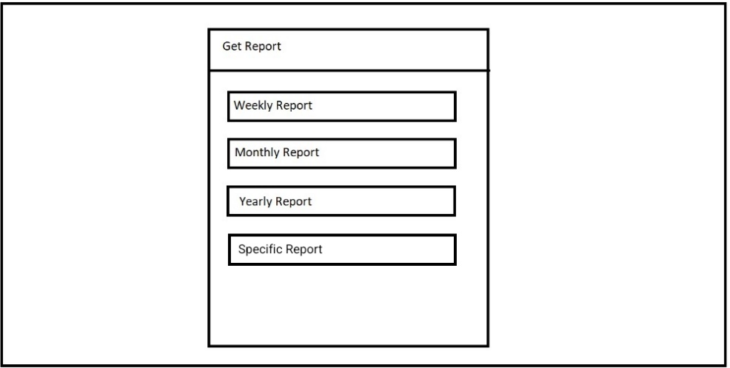

**Figure 3.8. Report generation page**

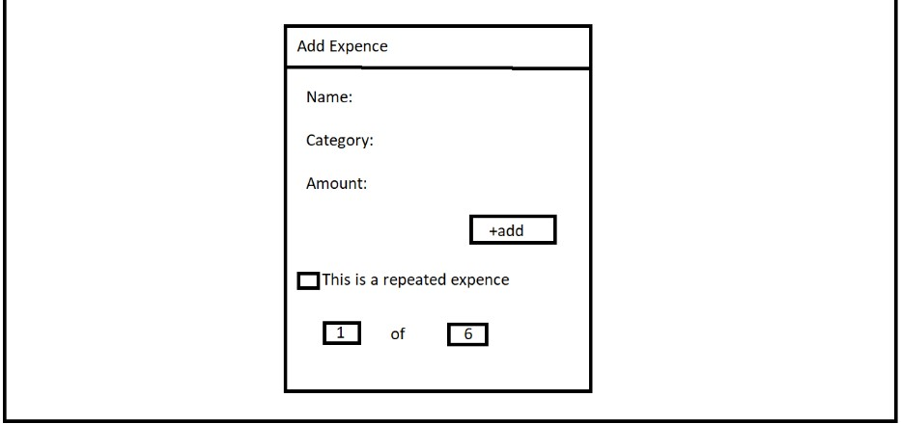

**Figure 3.9. Add expense page**

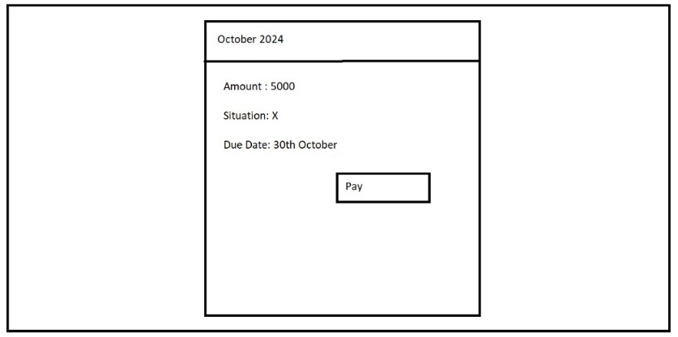

**Figure 3.10. Payment display page**

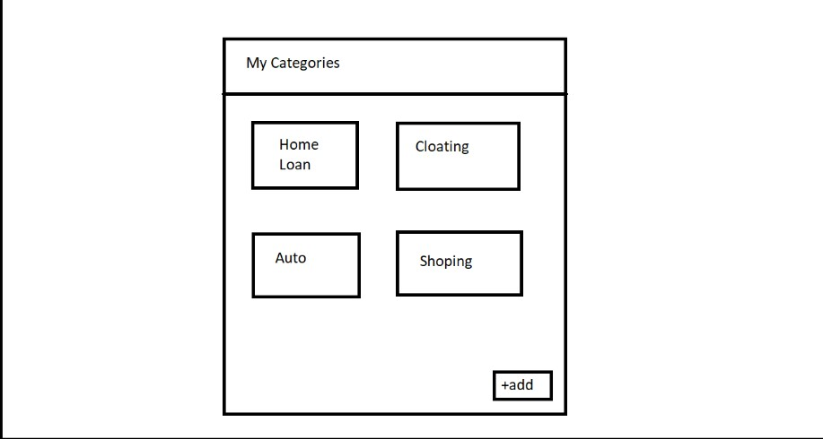

**Figure 3.11. Categories display page**

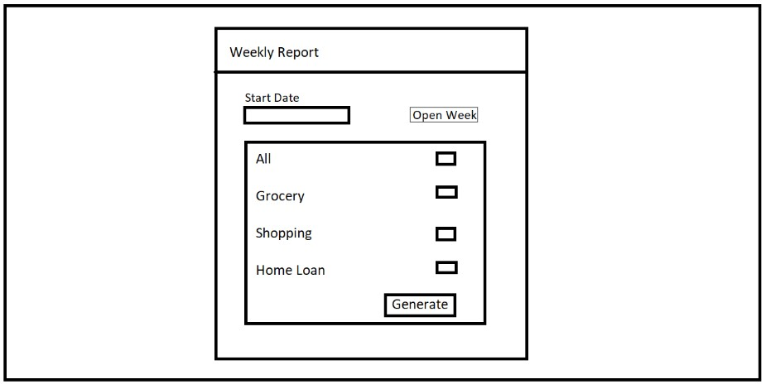

**Figure 3.12. Report display page**

# Conclusion

In this analysis report, functional and nonfunctional requirements are determined, some user scenarios are produced and use case diagrams of these scenarios are added, classes are planned to be used are listed and drafts of the user interface is included.

The draft preparation, design, and organization of the report were contributed by Furkan İÇTÜZER, Serhat ERDOĞAN, Selim ÇENTELİ, Sümeyye Feyza YEMENOĞLU, and Saidahmad USMANALIEV. The UML diagram was created by Furkan İÇTÜZER, the scenarios were developed by Sümeyye Feyza YEMENOĞLU, the use-case diagram was visualized by Selim ÇENTELİ, and the design for the interface was visualized by Serhat ERDOĞAN and Sümeyye Feyza YEMENOĞLU.